上机实验六
#include<iostream>
#include<string>
using namespace std;
class MyArray {
public:
MyArray(int length);
MyArray();
~MyArray();
void Input();
void Display(string);
int a[5];
protected:
int* alist;
int length;
};
class SortArray :public MyArray
{
public:
SortArray(int a):MyArray(a)
{
length = a;
cout << "SortArray类对象已创建!" << endl;
}
~SortArray();
void dis(string);
void px();
private :
int b;
};
void SortArray::px()
{
int i, j, temp;
for (i = 0; i < length - 1; i++)
for (j = 0; j < length - i - 1; j++)
{
if (a[j] > a[j + 1])
{
temp = a[j];
a[j] = a[j + 1];
a[j + 1] = temp;
}
}
cout << "显示排序以后的的五个整数";
for (i = 0; i < 5; i++)
cout << a[i] << " ";
cout << endl;
}
void SortArray::dis(string str)
{
int i;
int* p = alist;
cout << str << length << "个整数: ";
for (i = 0; i < length; i++, p++)
cout << *p << " ";
cout << endl;
}
SortArray::~SortArray()
{
cout << "SortArray类对象已撤销!" << endl;
}
MyArray::MyArray()
{

}
MyArray::MyArray(int leng)
{
if (leng <= 0)
{
cout << "error length";
exit(1);
}
length = leng;
alist = new int[length];

if (alist == NULL)
{
cout << "assign failure";
exit(1);
}
cout << "MyArray类对象已创建!" << endl;
}
MyArray::~MyArray()
{
delete[] alist;
cout << "MyArray类对象已撤销!" << endl;
}
void MyArray::Display(string str)
{
int i;
int* p = alist;
cout << str << length << "个整数: ";
for (i = 0; i < length; i++, p++)
cout << *p << " ";

cout << endl;
}
void MyArray::Input()
{
cout << "请从键盘输入" << length << "个整数:";
int i;
int* p = alist;
for (i = 0; i < length; i++, p++)
{
cin >> *p;
a[i] = *p;
}
}
int main()
{
SortArray a(5);
a.Input();
a.Display("显示已经输入的");
a.dis("显示排序以前的");
a.px();
return 0;
}

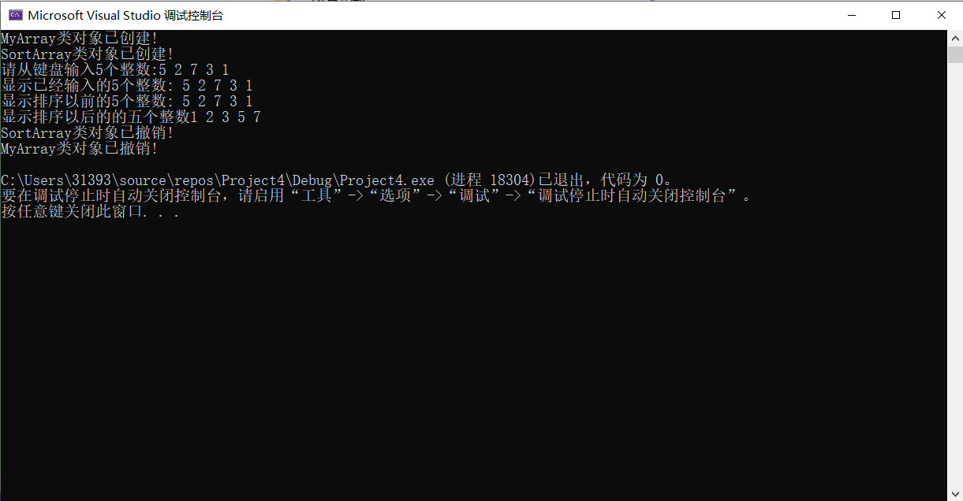

上机感受
这次实验让我明白了派生类的构造函数与析构函数的执行顺序：先构造函数再析构函数，由于即使编译构造函数后未定义析构函数，系统也会自动定义一个析构函数，因此平时我们基本无法很深入地了解析构函数，但本次实验通过自己定义一个析构函数，让我能够实实在在地看到构造函数与析构函数的执行顺序。

Copyright @2021-2099 dongzhenzhou. All rights reserved

